**Question 1**

Single Link Proximity:

In Single Linkage**,** thedistance between two clusters is the minimum distance between members of the two clusters

|  |  |  |  |  |  |  |  |  |  |  |  |
| --- | --- | --- | --- | --- | --- | --- | --- | --- | --- | --- | --- |
|  | | **p1** | | **p2** | | **p3** | | **p4** | | **p5** | **p6** |
| **p1** | | 0 | | 0.2357 | | 0.2218 | | 0.3688 | | 0.3421 | 0.2347 |
| **p2** | | 0.2357 | | 0 | | 0.1483 | | 0.2042 | | 0.1388 | 0.254 |
| **p3** | | 0.2218 | | 0.1483 | | 0 | | 0.1513 | | 0.2843 | 0.11 |
| **p4** | | 0.3688 | | 0.2042 | | 0.1513 | | 0 | | 0.2932 | 0.2216 |
| **p5** | | 0.3421 | | 0.1388 | | 0.2843 | | 0.2932 | | 0 | 0.3921 |
| **p6** | | 0.2347 | | 0.254 | | 0.11 | | 0.2216 | | 0.3921 | 0 |
|  | |  | |  | |  | |  | |  |  |
| smallest distance is | | | | | | | | | | 0.11 |  |
| so p3 and p6 forms first cluster | | | | | | | | | | |
|  | **p1** | | **p2** | | **p36** | | **p4** | | **p5** | |
| **p1** | 0 | | 0.2357 | | 0.2218 | | 0.3688 | | 0.3421 | |
| **p2** | 0.2357 | | 0 | | 0.1483 | | 0.2042 | | 0.1388 | |
| **p36** | 0.2218 | | 0.1483 | | 0 | | 0.1513 | | 0.2843 | |
| **p4** | 0.3688 | | 0.2042 | | 0.1513 | | 0 | | 0.2932 | |
| **p5** | 0.3421 | | 0.1388 | | 0.2843 | | 0.2932 | | 0 | |
|  |  | |  | |  | |  | |  | |
| smallest distance is | | | | | | | | | 0.1388 | |

|  |  |  |  |  |  |
| --- | --- | --- | --- | --- | --- |
| so p2 and p5 forms 2nd cluster | | | | | |
|  | **p1** | **p25** | **p36** | **p4** |  |
| **p1** | 0 | 0.2357 | 0.2218 | 0.3688 |  |
| **p25** | 0.2357 | 0 | 0.1483 | 0.2042 |  |
| **p36** | 0.2218 | 0.1483 | 0 | 0.1513 |  |
| **p4** | 0.3688 | 0.2042 | 0.1513 | 0 |  |
|  |  |  |  |  |  |
| smallest distance is | | | | | 0.1483 |
| so p25 and p36 forms 3rdcluster | | | | | |
|  |  |  |  |  |  |
|  | **p1** | **p(25)(36)** | **p4** |  |  |
| **p1** | 0 | 0.2218 | 0.3688 |  |  |
| **p(25)(36)** | 0.2218 | 0 | 0.1513 |  |  |
| **p4** | 0.3688 | 0.1513 | 0 |  |  |
|  |  |  |  |  |  |
| smallest distance is | | | | | 0.153 |
| so p(25)(36)and p4 forms 4thcluster | | | | | |
|  | **p1** | **p4(25)(36)** |  |  |  |
| **p1** | 0 | 0.2218 |  |  |  |
| **p4(25)(36)** | 0.2218 | 0 |  |  |  |

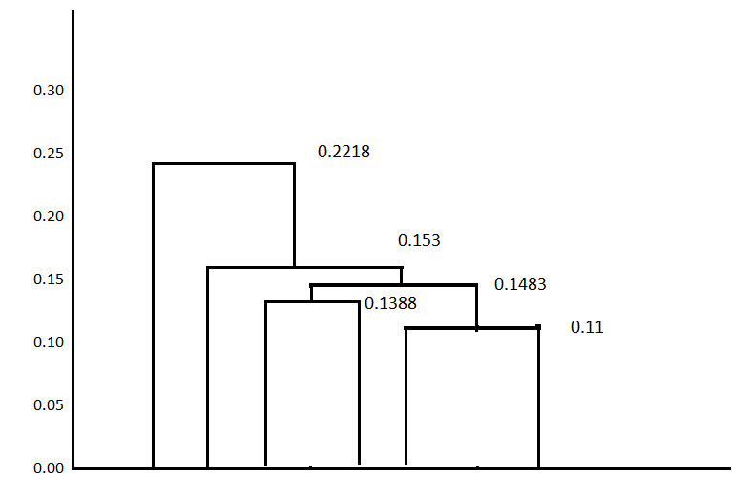

**1 4 2 5 3 6**

Complete Link Proximity:

* In Complete Linkage**,**the distance between two clusters is the maximum distance between members of the two clusters

|  |  |  |  |  |  |  |
| --- | --- | --- | --- | --- | --- | --- |
|  | **p1** | **p2** | **p3** | **p4** | **p5** | **p6** |
| **p1** | 0 | 0.2357 | 0.2218 | 0.3688 | 0.3421 | 0.2347 |
|  |  |  |  |  |  |  |
|  |  |  |  |  |  |  |
| **p2** | 0.2357 | 0 | 0.1483 | 0.2042 | 0.1388 | 0.254 |
| **p3** | 0.2218 | 0.1483 | 0 | 0.1513 | 0.2843 | 0.11 |
| **p4** | 0.3688 | 0.2042 | 0.1513 | 0 | 0.2932 | 0.2216 |
| **p5** | 0.3421 | 0.1388 | 0.2843 | 0.2932 | 0 | 0.3921 |
| **p6** | 0.2347 | 0.254 | 0.11 | 0.2216 | 0.3921 | 0 |
|  |  |  |  |  |  |  |
| smallest distance is | | | | | 0.11 |  |
| so p3 and p6 forms first cluster | | | | | |  |
|  | **p1** | **p2** | **p36** | **p4** | **p5** |  |
| **p1** | 0 | 0.2357 | 0.2347 | 0.3688 | 0.3421 |  |
| **p2** | 0.2357 | 0 | 0.254 | 0.2042 | 0.1388 |  |
| **p36** | 0.2347 | 0.254 | 0 | 0.2216 | 0.3921 |  |
| **p4** | 0.3688 | 0.2042 | 0.2216 | 0 | 0.2932 |  |
| **p5** | 0.3421 | 0.1388 | 0.3921 | 0.2932 | 0 |  |
|  |  |  |  |  |  |  |
| smallest distance is | | | | | 0.1388 |  |
| so p2 and p5 forms 2nd cluster | | | | | |  |
|  | **p1** | **p25** | **p36** | **p4** |  |  |
| **p1** | 0 | 0.3421 | 0.2347 | 0.3688 |  |  |
| **p25** | 0.3421 | 0 | 0.3921 | 0.2932 |  |  |
| **p36** | 0.2347 | 0.3921 | 0 | 0.2216 |  |  |
| **p4** | 0.3688 | 0.2932 | 0.2216 | 0 |  |  |
|  |  |  |  |  |  |  |
| smallest distance is | | | | | 0.2216 |  |
| so p25 and p36 forms 3rdcluster | | | | | |  |
|  | **p1** | **p(25)(36)** | **p4** |  |  |  |
| **p1** | 0 | 0.3421 | 0.3688 |  |  |  |
| **p(25)(36)** | 0.3421 | 0 | 0.2932 |  |  |  |
| **p4** | 0.3688 | 0.2932 | 0 |  |  |  |
|  |  |  |  |  |  |  |
| smallest distance is | | | | | 0.2932 |  |
| so p(25)(36)and p1 forms 4thcluster | | | | | |  |
|  | **p1(25)(36)** | **p4** |  |  |  |  |
| **p1(25)(36)** | 0 | 0.1483 |  |  |  |  |
| **p4** | 0.3688 | 0 |  |  |  |  |

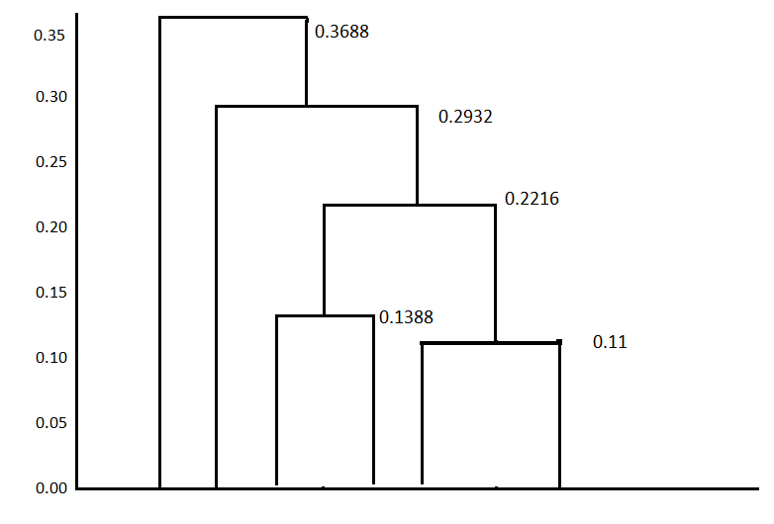

**4 1 2 5 3 6**

Average Link Proximity:

* In Average Linkage**,**the distance between two clusters is the average of all distances between members of the two clusters

|  |  |  |  |  |  |  |
| --- | --- | --- | --- | --- | --- | --- |
|  | **p1** | **p2** | **p3** | **p4** | **p5** | **p6** |
| **p1** | 0 | 0.2357 | 0.2218 | 0.3688 | 0.3421 | 0.2347 |
| **p2** | 0.2357 | 0 | 0.1483 | 0.2042 | 0.1388 | 0.254 |
| **p3** | 0.2218 | 0.1483 | 0 | 0.1513 | 0.2843 | 0.11 |
| **p4** | 0.3688 | 0.2042 | 0.1513 | 0 | 0.2932 | 0.2216 |
| **p5** | 0.3421 | 0.1388 | 0.2843 | 0.2932 | 0 | 0.3921 |
| **p6** | 0.2347 | 0.254 | 0.11 | 0.2216 | 0.3921 | 0 |
|  |  |  |  |  |  |  |
| smallest distance is | | | | | 0.11 |  |
| so p3 and p6 forms first cluster | | | | | |  |
|  | **p1** | **p2** | **p36** | **p4** | **p5** |  |
| **p1** | 0 | 0.2357 | 0.22825 | 0.3688 | 0.3421 |  |
| **p2** | 0.2357 | 0 | 0.20115 | 0.2042 | 0.1388 |  |
| **p36** | 0.22825 | 0.20115 | 0 | 0.18645 | 0.3382 |  |
| **p4** | 0.3688 | 0.2042 | 0.18645 | 0 | 0.2932 |  |
| **p5** | 0.3421 | 0.1388 | 0.3382 | 0.2932 | 0 |  |
|  |  |  |  |  |  |  |
| smallest distance is | | | | | 0.1388 |  |
| so p2 and p5 forms 2nd cluster | | | | | |  |
|  | **p1** | **p25** | **p36** | **p4** |  |  |
| **p1** | 0 | 0.2889 | 0.2347 | 0.3688 |  |  |
| **p25** | 0.2889 | 0 | 0.269675 | 0.2487 |  |  |
| **p36** | 0.2347 | 0.269675 | 0 | 0.18645 |  |  |
| **p4** | 0.3688 | 0.2487 | 0.18645 | 0 |  |  |
|  |  |  |  |  |  |  |
| smallest distance is | | | | | 0.18645 |  |
| so p25 and p36 forms 3rdcluster | | | | | |  |
|  | **p1** | **p(25)(36)** | **p4** |  |  |  |
| **p1** | 0 | 0.2618 | 0.3688 |  |  |  |
| **p(25)(36)** | 0.2618 | 0 | 0.217575 |  |  |  |
| **p4** | 0.3688 | 0.217575 | 0 |  |  |  |
|  |  |  |  |  |  |  |
| smallest distance is | | | | | 0.217575 |  |
| so p(25)(36)and p1 forms 4thcluster | | | | | |  |
|  | **p1(25)(36)** | **p4** |  |  |  |  |
| **p1(25)(36)** | 0 | 0.3153 |  |  |  |  |
| **p4** | 0.3153 | 0 |  |  |  |  |

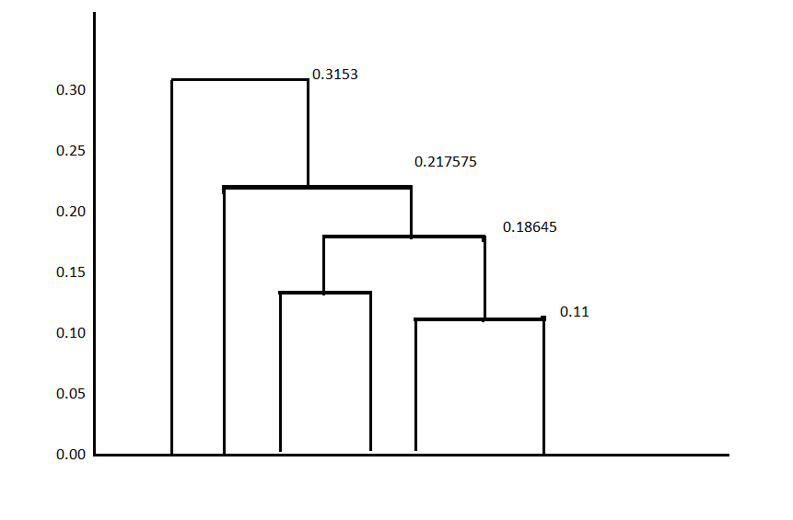 **4 1 2 5 3 6**

**Question 2**

1. Read the csv file and replace all the null values with the mean value

1. Apply StandardScaler() and normalize() functions to scale and normalize the raw input data.

1. Apply Agglomerative Clustering with k=2,3,4 and 5 on reduced features and visualize result for each k value using scatter plot.

For K=2

K=3

K=4

K=5

Evaluating different variations using Silhouette Scores and visualizing the results with a bar chart.

GitHub Link:

Video Link: